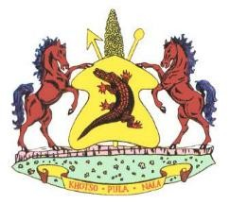
Lesotho permit number…………………………………….

VETERINARY HEALTH ATTESTATION FOR TURKEY MEAT

I……………………………………………………………………………………………………………. the undersigned veterinary/official authorized by the Director of Veterinary Services in South Africa attest the following:
- The turkey meat was derived from birds which were hatched, reared and slaughtered in South Africa;
- The birds must have originated from farms not under any veterinary restrictions for any disease to which the avian are susceptible;
- Originate from an area free from new castle Disease (NCD) or any contagious disease;
- The birds were slaughtered and processed at an abattoir with approved export slaughter and processing facilities. The turkey meat must have been inspected by qualified government meat inspectors and found fit for human consumption;
- All packaging / wrapping must bear the official inspection stamp of the slaughter plant;
- The vehicle transporting meat must conforms to acceptable standard of cleanliness, construction, maintenance; and be equipped with a continuous registering thermograph;
- The turkey meat must be loaded and sealed under the supervision of authorized officials and the seal number is indicated on the international veterinary certificate for export.

Seal No………………………………………………………………………………….

Vehicle No…………………………………………………………………………….

- The exporter/importer has been informed to undertake to inform the government veterinary officials nearest to the point of destination, so that she/he could unseal and check the consignment before it is disposed of in any way.
- The permit is valid for 30 days from date of issue and is for one consignment only.
Signed at……………………………………………………………………… On date………………………………………………………………………
__________________________________________
Authorized Veterinary /Official
Name in print………………………………………………………………….
Designated Rank……………………………………………………………….
Address……………………………………………………………………………. Official Stamp

